Random Forest Algorithm

What is Random Forest Algorithm?
Random Forest is one of the most popular and commonly used algorithms by Data Scientists. Random forest is a Supervised Machine Learning Algorithm that is used widely in Classification and Regression problems. It builds decision trees on different samples and takes their majority vote for classification and average in case of regression.
Random forest is a versatile machine learning algorithm developed by Leo Breiman and Adele Cutler. It leverages an ensemble of multiple decision trees to generate predictions or classifications. By combining the outputs of these trees, the random forest algorithm delivers a consolidated and more accurate result.
Its widespread popularity stems from its user-friendly nature and adaptability, enabling it to tackle both classification and regression problems effectively. The algorithm’s strength lies in its ability to handle complex datasets and mitigate overfitting, making it a valuable tool for various predictive tasks in machine learning.
One of the most important features of the Random Forest Algorithm is that it can handle the data set containing continuous variables, as in the case of regression, and categorical variables, as in the case of classification. It performs better for classification and regression tasks.

Real-Life Analogy of Random Forest
Let’s dive into a real-life analogy to understand this concept further. A student named X wants to choose a course after his 10+2, and he is confused about the choice of course based on his skill set. So, he decides to consult various people like his cousins, teachers, parents, degree students, and working people. He asks them varied questions like why he should choose, job opportunities with that course, course fee, etc. Finally, after consulting various people about the course he decides to take the course suggested by most people.
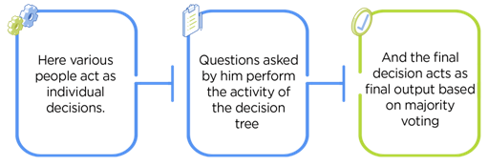
The name "Random Forest" actually stems from the way the algorithm operates. It's a machine learning technique that builds multiple decision trees during training and merges them together to get a more accurate and stable prediction. Each decision tree in the forest is built using a random subset of the training data and a random subset of the features. So, the "random" in Random Forest refers to this randomness in both data sampling and feature selection.

Working of Random Forest Algorithm
Before understanding the working of the random forest algorithm in machine learning, we must look into the ensemble learning technique. Ensemble simply means combining multiple models. Thus, a collection of models is used to make predictions rather than an individual model.
Ensemble uses two types of methods:
1. Bagging– It creates a different training subset from sample training data with replacement & the final output is based on majority voting. For example, Random Forest.
2. Boosting– It combines weak learners into strong learners by creating sequential models such that the final model has the highest accuracy. For example, ADA BOOST, XG BOOST.
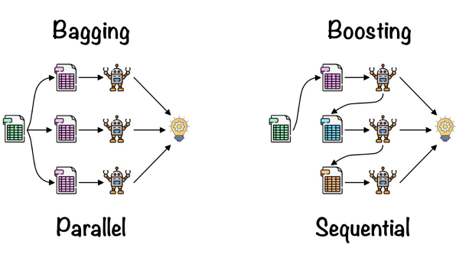
As mentioned earlier, Random Forest works on the Bagging principle. Now let’s dive in and understand bagging in detail.

Bagging
Bagging, also known as Bootstrap Aggregation, is the ensemble technique used by random forest. Bagging chooses a random sample/random subset from the entire data set. Hence each model is generated from the samples (Bootstrap Samples) provided by the Original Data with replacement known as row sampling. This step of row sampling with replacement is called bootstrap. Now each model is trained independently, which generates results. The final output is based on majority voting after combining the results of all models. This step which involves combining all the results and generating output based on majority voting, is known as aggregation.
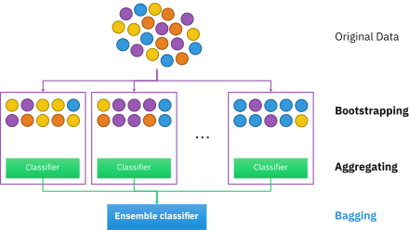
Now let’s look at an example by breaking it down with the help of the following figure. Here the bootstrap sample is taken from actual data (Bootstrap sample 01, Bootstrap sample 02, and Bootstrap sample 03) with a replacement which means there is a high possibility that each sample won’t contain unique data. The model (Model 01, Model 02, and Model 03) obtained from this bootstrap sample is trained independently. Each model generates results as shown. Now the Happy emoji has a majority when compared to the Sad emoji. Thus, based on majority voting final output is obtained as Happy emoji.
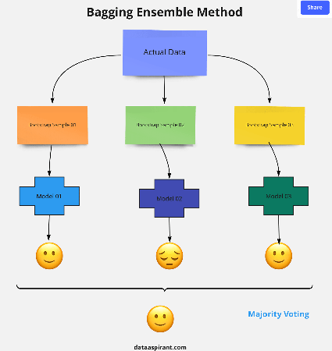

Boosting
Boosting is one of the techniques that use the concept of ensemble learning. A boosting algorithm combines multiple simple models (also known as weak learners or base estimators) to generate the final output. It is done by building a model by using weak models in series.
There are several boosting algorithms; AdaBoost was the first really successful boosting algorithm that was developed for the purpose of binary classification. AdaBoost is an abbreviation for Adaptive Boosting and is a prevalent boosting technique that combines multiple “weak classifiers” into a single “strong classifier.” There are Other Boosting techniques. For more, you can visit

Steps Involved in Random Forest Algorithm
Step 1: In the Random forest model, a subset of data points and a subset of features is selected for constructing each decision tree. Simply put, n random records and m features are taken from the data set having k number of records.
Step 2: Individual decision trees are constructed for each sample.
Step 3: Each decision tree will generate an output.
Step 4: Final output is considered based on Majority Voting or Averaging for Classification and regression, respectively.

For example: consider the fruit basket as the data as shown in the figure below. Now n number of samples are taken from the fruit basket, and an individual decision tree is constructed for each sample. Each decision tree will generate an output, as shown in the figure. The final output is considered based on majority voting. In the below figure, you can see that the majority decision tree gives output as an apple when compared to a banana, so the final output is taken as an apple.
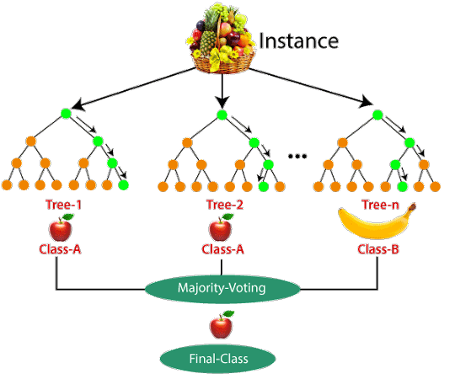
The scenario you've described is an example of an ensemble learning technique called "Bootstrap Aggregating" or "Bagging," and it's often used with Decision Trees. Let's break down how this works using a Decision Tree as an illustration:
- Fruit Basket Data: Imagine you have a dataset representing a fruit basket. Each data point in this dataset is a fruit characterized by features like size, color, and shape. The goal is to classify each fruit as either an apple or a banana based on these features.
- Sampling: You take multiple random samples (with replacement) from your fruit basket dataset. Each sample contains a subset of the fruits from the original dataset. This process creates multiple "bootstrap" datasets.
- Individual Decision Trees: For each of these bootstrap datasets, you build an individual Decision Tree. Each Decision Tree is trained on its respective bootstrap dataset and tries to learn patterns to classify fruits as accurately as possible.
- Predictions: After training, each Decision Tree is capable of making predictions on new, unseen fruits based on the patterns it learned during training.
- Majority Voting: Now, when you want to classify a new, unseen fruit, you pass it to all the individual Decision Trees. Each tree will make its prediction (e.g., one tree might say "apple," another might say "banana").
- Final Prediction: The final prediction is determined by majority voting. You count the votes from all the Decision Trees and select the class (apple or banana) that receives the most votes as the final prediction.
In your specific example, you mentioned that most Decision Trees classified the fruit as an "apple," so the majority vote is in favor of "apple," and that's the final prediction.
The advantage of this approach is that it combines the predictions from multiple models (Decision Trees) to reduce overfitting and improve the overall accuracy and robustness of the classification. It helps to mitigate the limitations of individual Decision Trees, such as their sensitivity to noise and outliers. This ensemble method is particularly effective when dealing with complex and noisy datasets.

Bagging (Bootstrap Aggregating):
- Parallel Model Building: Bagging constructs multiple base models (often decision trees) in parallel, where each model is trained on a random subset of the training data with replacement. This random sampling with replacement is called bootstrapping.
- Equal Weighting: In bagging, all base models are typically given equal weight when making predictions. This means each model contributes equally to the final prediction, and there's no preference for one model over another.
- Variance Reduction: Bagging aims to reduce the variance of the model. By creating diverse subsets of data and training multiple models on them, it helps mitigate overfitting and results in a more stable and accurate ensemble model.
- Examples: Random Forest is a well-known ensemble technique that uses bagging to build multiple decision trees and aggregate their predictions.
Boosting:
- Sequential Model Building: Boosting constructs multiple base models (often weak learners) in a sequential manner. Each model is trained on the entire training dataset, but with different weights assigned to the data points. Misclassified data points are given more weight, so subsequent models focus on the previously misclassified examples.
- Weighted Voting: In boosting, each base model is assigned a weight based on its performance. Models that perform well on the training data are given higher weight, while poorly performing models receive lower weight. The final prediction is made by weighted voting, where models with higher weights have more influence.
- Bias Reduction: Boosting aims to reduce both bias and variance. It focuses on improving the accuracy of the model, even at the cost of increasing variance. This makes boosting particularly effective for reducing bias in complex models.
- Examples: AdaBoost and Gradient Boosting (e.g., XGBoost, LightGBM) are popular boosting algorithms.
In summary, the main differences between bagging and boosting are in their data sampling and model weighting strategies. Bagging builds parallel models with equal weighting, aiming to reduce variance, while boosting builds sequential models with weighted voting, focusing on bias reduction and improving model accuracy. Each approach has its strengths and is suited to different types of problems.

Important Features of Random Forest
- Diversity: Not all attributes/variables/features are considered while making an individual tree; each tree is different.
- Immune to the curse of dimensionality: Since each tree does not consider all the features, the feature space is reduced.
- Parallelization: Each tree is created independently out of different data and attributes. This means we can fully use the CPU to build random forests.
- Train-Test split: In a random forest, we don’t have to segregate the data for train and test as there will always be 30% of the data which is not seen by the decision tree.
- Stability: Stability arises because the result is based on majority voting/ averaging.
The "curse of dimensionality" is a term used in mathematics and machine learning to describe various challenges and problems that arise when working with high-dimensional data, particularly in spaces with many features or dimensions. It refers to the fact that as the number of dimensions (features) in a dataset increases, certain phenomena occur that can make data analysis and machine learning tasks more difficult. Here are some key aspects of the curse of dimensionality:
- Data Sparsity: In high-dimensional spaces, data points tend to become increasingly sparse. As the number of dimensions grows, the volume of the space increases exponentially. This means that data points are more spread out, making it harder to find meaningful patterns or clusters.
- Increased Computational Complexity: High-dimensional datasets require significantly more computational resources for processing, storage, and analysis. Algorithms that work efficiently in low-dimensional spaces may become impractical or slow in high-dimensional spaces.
- Overfitting: Models trained on high-dimensional data are more susceptible to overfitting. With many features, a model can find spurious correlations in the data that do not generalize well to new, unseen data. This can lead to poor model performance.
- Diminishing Returns: Adding more dimensions to a dataset does not always lead to improved model performance. There is a point of diminishing returns, where additional features provide little or no additional information, yet they increase the complexity of the data and models.
- Curse of Sample Size: As the dimensionality increases, the amount of data required to obtain a representative sample also increases. In high-dimensional spaces, the data available may be insufficient to adequately cover the space, leading to sampling bias.
- Distance Metric Challenges: Distance-based algorithms and metrics become less effective in high-dimensional spaces. In high dimensions, all data points tend to be approximately equidistant from each other, making it difficult to distinguish between similar and dissimilar points.
- Increased Noise Sensitivity: High-dimensional data is more susceptible to noise and outliers, which can have a disproportionately large impact on model performance.

Difference Between Decision Tree and Random Forest
Random forest is a collection of decision trees; still, there are a lot of differences in their behavior.
Decision trees | Random Forest
1. Decision trees normally suffer from the problem of overfitting if it’s allowed to grow without any control. | 1. Random forests are created from subsets of data, and the final output is based on average or majority ranking; hence the problem of overfitting is taken care of.
2. A single decision tree is faster in computation. | 2. It is comparatively slower.
3. When a data set with features is taken as input by a decision tree, it will formulate some rules to make predictions. | 3. Random Forest randomly selects observations, builds a decision tree, and takes the average result. It doesn’t use any set of formulas.
Thus random forests are much more successful than decision trees only if the trees are diverse and acceptable.

Important Hyperparameters in Random Forest
Hyperparameters are used in random forests to either enhance the performance and predictive power of models or to make the model faster.

Hyperparameters to Increase the Predictive Power
n_estimators: Number of trees the algorithm builds before averaging the predictions.
max_features: Maximum number of features random forest considers splitting a node.
mini_sample_leaf: Determines the minimum number of leaves required to split an internal node.
criterion: How to split the node in each tree? (Entropy/Gini impurity/Log Loss)
max_leaf_nodes: Maximum leaf nodes in each tree

Hyperparameters to Increase the Speed
n_jobs: it tells the engine how many processors it is allowed to use. If the value is 1, it can use only one processor, but if the value is -1, there is no limit.
random_state: controls randomness of the sample. The model will always produce the same results if it has a definite value of random state and has been given the same hyperparameters and training data.
oob_score: OOB means out of the bag. It is a random forest cross-validation method. In this, one-third of the sample is not used to train the data; instead used to evaluate its performance. These samples are called out-of-bag samples.

Random Forest Algorithm Use Cases
This algorithm is widely used in E-commerce, banking, medicine, the stock market, etc.
For example: In the Banking industry, it can be used to find which customer will default on a loan.

Advantages and Disadvantages of Random Forest Algorithm

Advantages
1. It can be used in classification and regression problems.
2. It solves the problem of overfitting as output is based on majority voting or averaging.
3. It performs well even if the data contains null/missing values.
4. Each decision tree created is independent of the other; thus, it shows the property of parallelization.
5. It is highly stable as the average answers given by a large number of trees are taken.
6. It maintains diversity as all the attributes are not considered while making each decision tree though it is not true in all cases.
7. It is immune to the curse of dimensionality. Since each tree does not consider all the attributes, feature space is reduced.
8. We don’t have to segregate data into train and test as there will always be 30% of the data, which is not seen by the decision tree made out of bootstrap.

Disadvantages
1. Random Forest is highly complex compared to decision trees, where decisions can be made by following the path of the tree.
2. Training time is more than other models due to its complexity. Whenever it has to make a prediction, each decision tree has to generate output for the given input data.

Conclusion
Random forest is a great choice if anyone wants to build the model fast and efficiently, as one of the best things about the random forest is it can handle missing values. It is one of the best techniques with high performance, widely used in various industries for its efficiency. It can handle binary, continuous, and categorical data. Overall, random forest is a fast, simple, flexible, and robust model with some limitations.
Key Takeaways
- Random forest algorithm is an ensemble learning technique combining numerous classifiers to enhance a model’s performance.
- Random Forest is a supervised machine-learning algorithm made up of decision trees.
- Random Forest is used for both classification and regression problems.
Maths behind Random Forest
Random Forest is an ensemble learning method used for both classification and regression tasks. It is based on the concept of decision trees and combines multiple decision trees to make more accurate predictions. Here are the key mathematical components behind Random Forest:

Decision Trees: Decision trees are the building blocks of Random Forest. Each decision tree is a flowchart-like structure that makes decisions by splitting data based on feature values. Decision trees partition the data into subsets and assign labels or predict values based on the majority class or average within each subset.
Bootstrapping (Random Sampling with Replacement): Random Forest uses bootstrapping to create multiple subsets of the original dataset. Each subset is the same size as the original dataset but is generated by randomly selecting data points with replacement. This process ensures that each decision tree in the forest is trained on a slightly different dataset.
Feature Randomness: In addition to bootstrapping, Random Forest introduces randomness in feature selection. Instead of considering all features at each split, it randomly selects a subset of features to be considered for splitting. This helps in reducing the correlation between decision trees and increasing the diversity of the forest.
Ensemble Averaging: Random Forest builds multiple decision trees independently. For classification tasks, each tree makes a prediction, and the class with the most votes (mode) across all trees is chosen as the final prediction. For regression tasks, each tree predicts a continuous value, and the average or median of these values is taken as the final prediction.
Bias-Variance Tradeoff: Random Forest mitigates the overfitting problem typically associated with single decision trees. By averaging the predictions of multiple trees, it reduces variance and improves generalization while maintaining a certain level of bias.
Out-of-Bag (OOB) Error Estimation: Random Forest uses the OOB error to estimate the model's performance without the need for a separate validation set. The OOB error is calculated by evaluating each data point's prediction on the decision trees that did not include that data point during training.
Tree Growth Stopping Criteria: Decision trees in a Random Forest may have different depths, but they are typically grown until a certain stopping criterion is met, such as maximum depth, minimum samples per leaf, or minimum samples per split.

Aggregation of Predictions: For classification tasks, the final prediction is often determined by a majority vote among the decision trees. For regression tasks, the final prediction is based on averaging the predictions from individual trees.

In summary, Random Forest combines multiple decision trees through bootstrapping and feature randomness to reduce overfitting and improve prediction accuracy. The ensemble averaging and aggregation of predictions from individual trees make it a powerful machine learning algorithm for various tasks.
Random Forest Regression:
Objective: In Random Forest regression, the goal is to predict a continuous numerical output, often referred to as the target or dependent variable.
Prediction Process: Each decision tree in the Random Forest makes continuous predictions. The final prediction is typically the average (mean) of the predictions from all the trees in the forest.
Output: The output of Random Forest regression is a continuous value. It's used for tasks like predicting house prices, temperature, stock prices, etc.
Random Forest Classification:

Objective: In Random Forest classification, the goal is to classify input data points into one of several predefined classes or categories.
Prediction Process: Each decision tree in the Random Forest assigns a class label to the input data point. The final prediction is determined by majority voting: the class that receives the most votes across all trees is selected as the final prediction.
Output: The output of Random Forest classification is a discrete class label. It's used for tasks like spam email detection, image classification, disease diagnosis, etc.
In summary, the main difference between Random Forest regression and classification is the type of output they produce. Regression predicts continuous values, while classification predicts discrete class labels. The underlying mechanism of using an ensemble of decision trees remains the same, but the way predictions are aggregated and interpreted differs based on the task's nature.
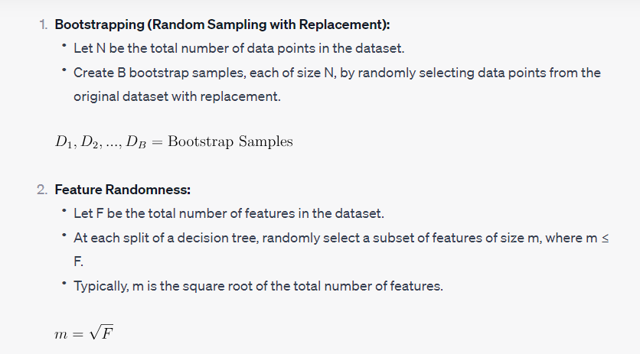
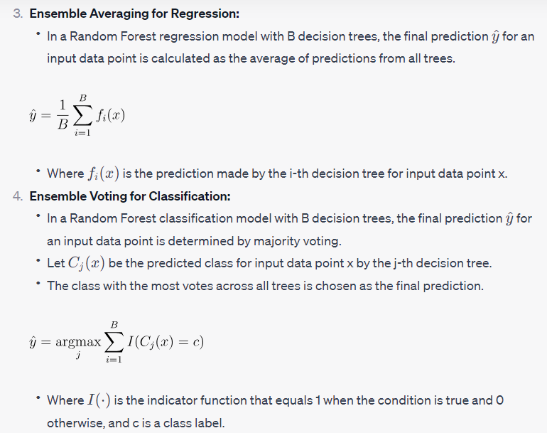
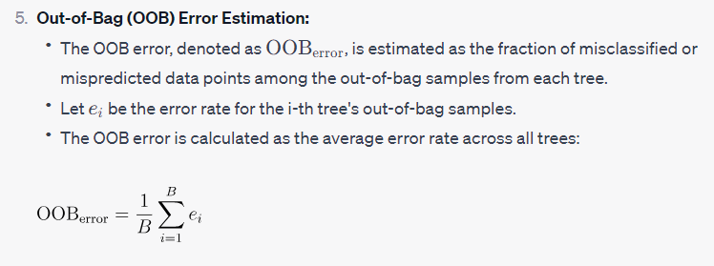

Dataset:
The four attributes mentioned in the context of banknote authentication represent statistical features extracted from an image of a banknote. Here's a brief explanation of each attribute:
Variance of the Image (Variance):
Variance is a statistical measure of how much the pixel values in an image vary from the mean pixel value. In the context of image processing, high variance indicates that the image has a lot of contrast or texture, while low variance suggests a more uniform region. For banknote authentication, the variance of specific image regions may carry information about certain security features.
Skewness of the Image (Skewness):
Skewness is a measure of the asymmetry in the distribution of pixel values within an image. It tells you whether the data is skewed to the left (negatively skewed), skewed to the right (positively skewed), or symmetrically distributed. Skewness can provide insights into the overall shape and structure of the image.
Entropy of the Image (Entropy):
Entropy is a measure of randomness or uncertainty in the pixel values of an image. In the context of images, higher entropy suggests more complex and less predictable patterns, while lower entropy indicates more uniform or predictable regions. Entropy can be useful for detecting irregularities or unexpected patterns in the banknote image.

Curtosis of the Image (Kurtosis or Curtosis):
Kurtosis measures the "tailedness" of the pixel value distribution. High kurtosis indicates that the pixel values have heavy tails and are more extreme, while low kurtosis suggests a flatter distribution. In image analysis, kurtosis can provide information about the presence of outliers or unusual pixel values in certain regions of the image.
These attributes are often used in image processing and machine learning to capture specific characteristics of images that may be relevant for classification or analysis tasks. In the case of banknote authentication, these attributes are used to train machine learning models that can distinguish between genuine and counterfeit banknotes based on the statistical patterns present in their images.

